**Fellowship Retreat at Launde Abbey 22nd – 24th March 2023**

A group retreat seems both a luxury and an essential part of nurturing one’s spiritual life. After the multiple challenges of living through the pandemic, our lovely gathering at Launde Abbey brought this home to me afresh.

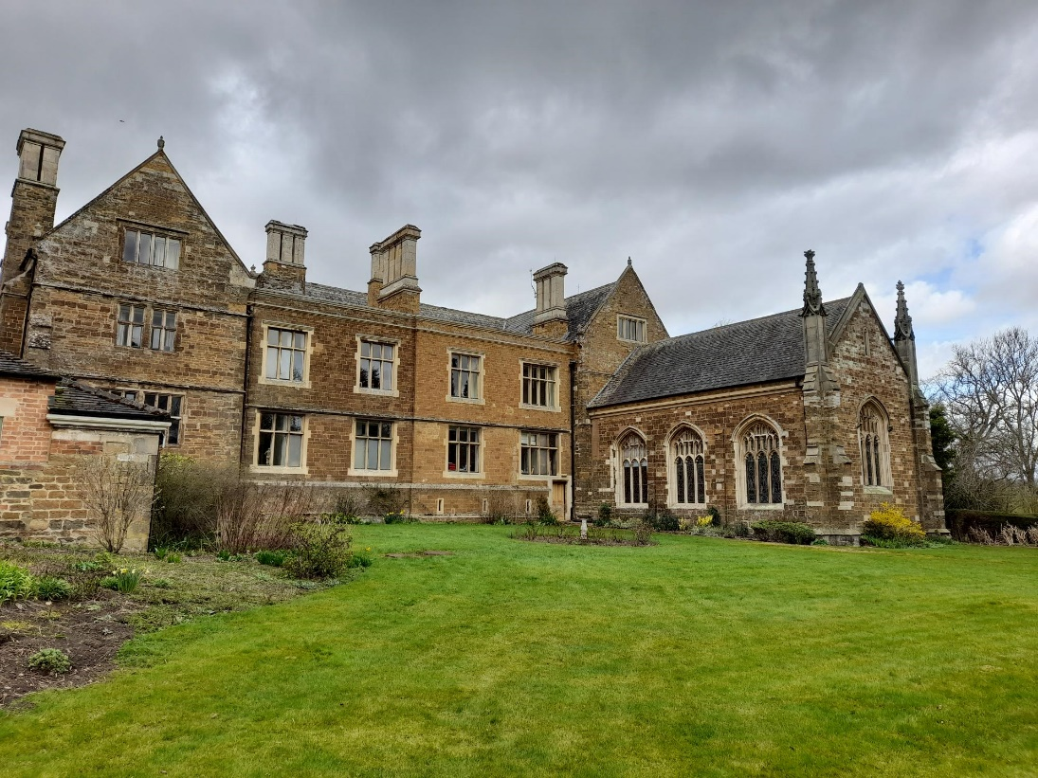

42 of us from 15 branches and scattered members were nourished spiritually, physically and socially, from the moment we arrived on Wednesday afternoon, to our departure after (a large and delicious) breakfast on Friday morning. For some it was a happy reunion; for others, their first time attending a national event. It was good to welcome husbands and our speaker’s wife, Sally Rawlinson.

We were led by the Revd Dr John Rawlinson, a medical doctor, priest and poet. In the first of four participatory sessions, he invited us to reflect on the stories Jesus told and share our favourite parables. During the second session, considering faith, religion and poetry, we shared our favourite poems after listening to some of John’s own poetry. His *Pandemic Triduum* was a highlight for many. The eclectic range of poems, new and old, humorous and profound made for an enjoyable and thought-provoking session.

The third session followed a similar format, with hymns and praise songs. There was a wonderful sense of unity as each favourite hymn was read, with a ripple of agreement or happy recognition greeting so many of the choices. There is indeed a hymn for every occasion! Our last session ‘rescue the perishing, care for the dying’ reflected on the practice of applied Christianity. John was an engaging, thought-provoking and entertaining leader.

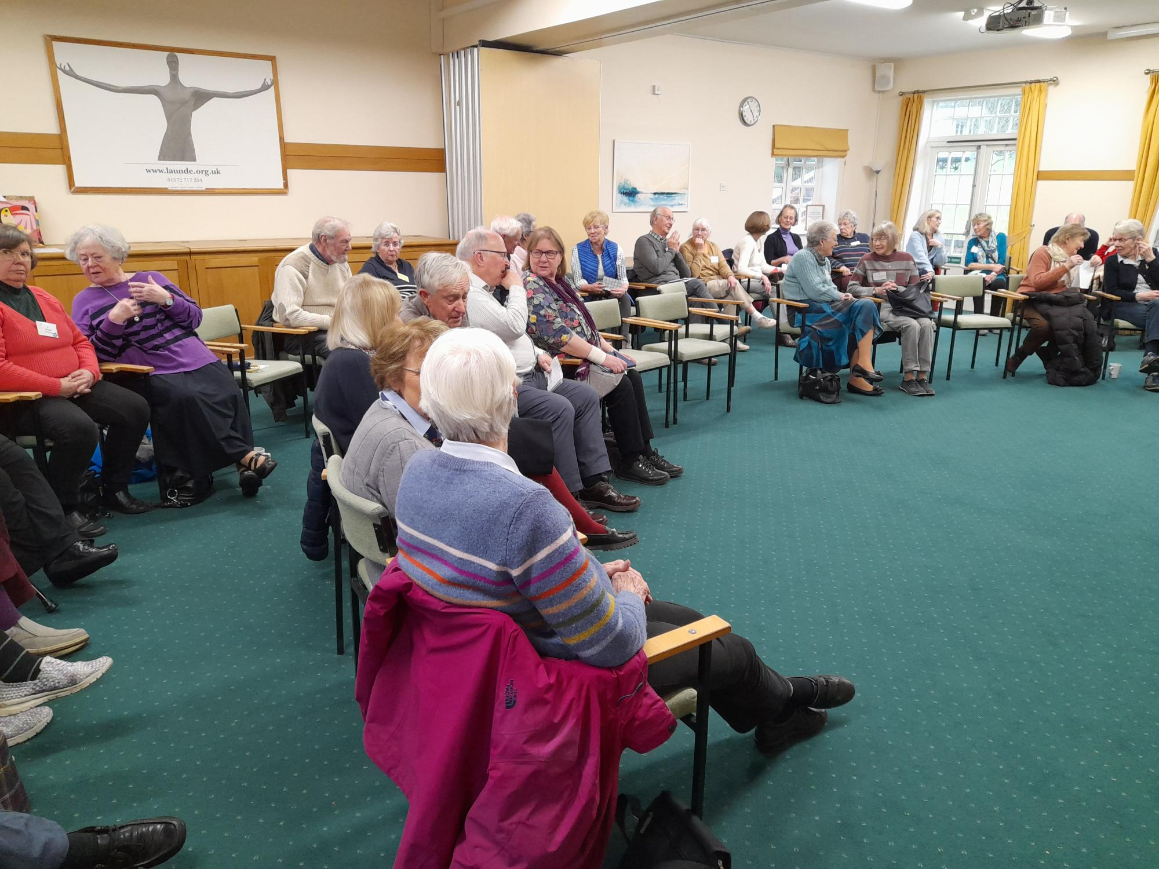

As with all WF events, there was plenty of time to socialise and enjoy good food. We moved from loud and cheerful conversations at meals, to quiet contemplation in the chapel and as the day ended, some of us talked late into the night on a wide range of topics. Joining the community for a Holy Communion service before breakfast was a special way to start the day and the officiating priest was impressed to see the chapel full!

The free session on Thursday afternoon was spent by some of us dodging (or failing to avoid) heavy showers as we explored the beautiful grounds of the Abbey, with the large walled garden, stations of the cross and the labyrinth which was bright with yellow daffodils. There were plenty of comfortable seating areas and also a well-stocked library and bar for those who did not want to venture outside.

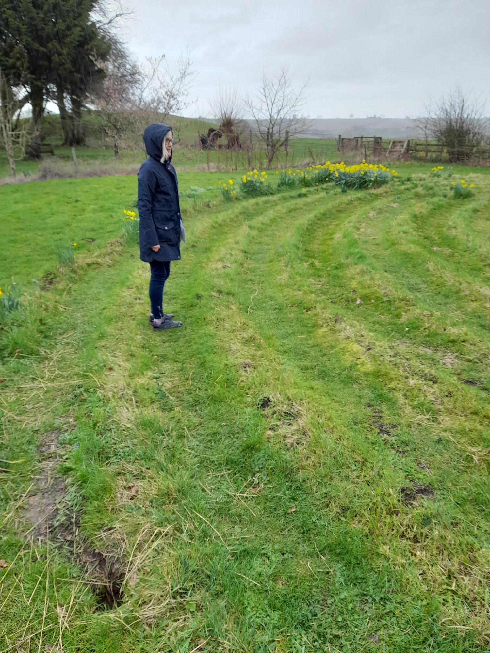

Thank you to the Revd Pamela Soult, for organising this retreat so brilliantly and giving us a chance to press ‘pause’ on our busy lives, re-set and be refreshed.